A Study of Supporting Characters in Animation- on American & Japanese Animation around 2000

Jihui Yan, Chulyong Choi

Department of Visual Contents, Division of Digital Contents
Graduate School of Dongseo University, Dongseo University
Busan, South Korea
ikkity@gmail.com, freechoi@hotmail.com

Abstract

Directing of supporting character and main character in animation shows clear difference in style and substance. Supporting characters lead the viewers to feel diverse emotions more intense and helps the development of storyline. More than leading characters, supporting characters approach the viewers with a greater sense of familiarity. Their action is often comic. This study examines the features and expressive styles of supporting characters in American and Japanese animations around 2000. Differences are analysed to read changes both in time and in region.

Keywords-component; supporting characters; development; type

I. Introduction

Supporting characters in animation take a wide range of images, from human beings and animals to plants and even the environment, which can deliver the director’s message and story background. There are often more than one supporting character which shape dramatic atmosphere around the main character. Supporting characters represent both good and negative values, supporting protagonists of good and evil.

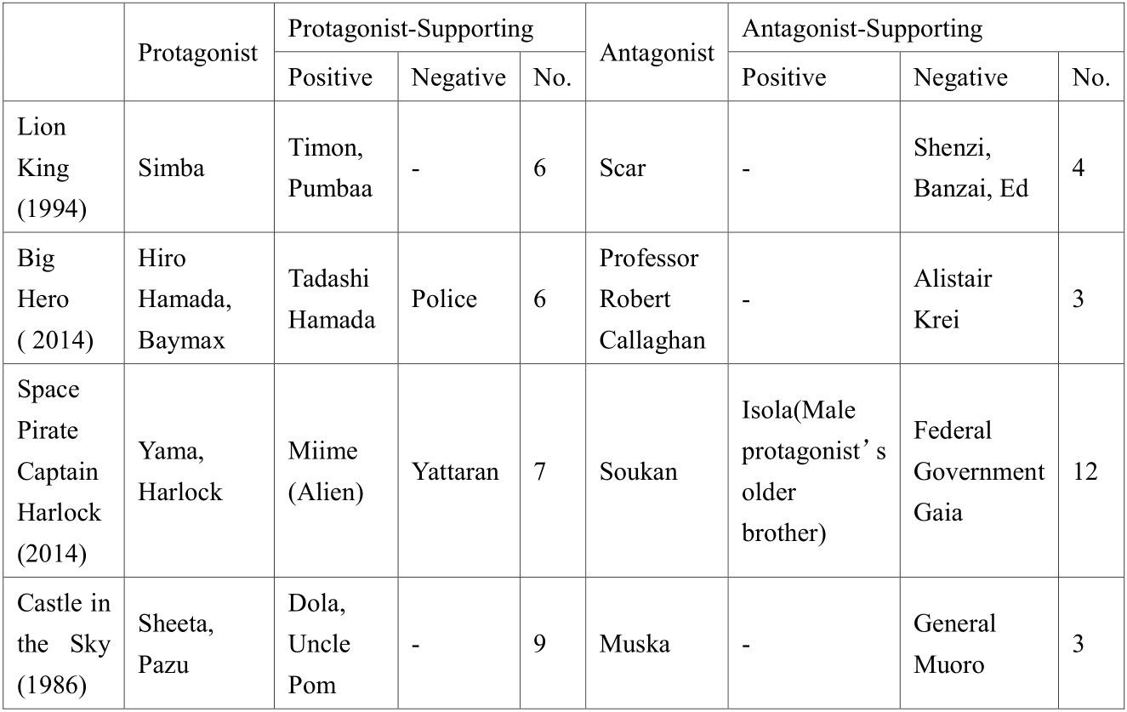

Fig. 1 Comparison of Supporting Characters by Period.

As supporting character’s image plays an important role in conveying information and emotions, some supporting characters are much bolder in character concept. The all-important first impression of an animation to the viewers is often determined not by background but by the appearance of characters; hence the design of supporting characters is at least as important as that of main characters. Their design must also aid storyline. The concept design of supporting characters expresses characters through various elements like shape, color, costume, psychology and world view; they mutually are complemented with main characters while also pursuing some degrees of differentiation.[1]

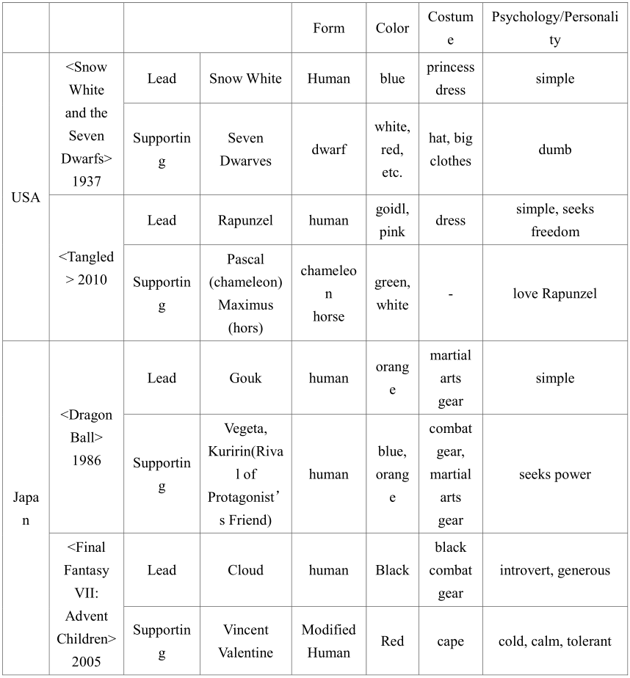

Fig. 2 Supporting Characters By Country Body.

II. Development of Supporting Characters

Classical animations mainly used characters from fairy tales and legends, as well as deified characters. Supporting characters lacked complex personality; they were mostly straightforward characters with clear distinction of good and evil. In recent times, however, supporting character images are no longer simple, as shown in Table 3. They have complex personalities and detailed description of psychology. The capriciousness and ambiguity about supporting characters enrich the storyline and endow it with a certain mystique to engage the audience and build dramatic tension. [2] For example, Kaonish and Yubaba in <Spirited Away> directed by Hayao Miyazaki, or Captain Dola in <Laputa: Castle in the Sky> show cold faces and action like villains, but they are in fact kind in heart. Such supporting characters represent real characters from our lives, further engaging the audience.

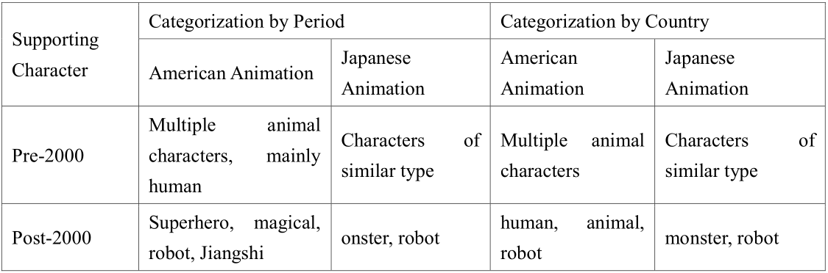
Fig. 3 Comparison of Supporting Characters around 2000.

III. Types and Working of Supporting Characters

Combination of main character and supporting character with different personalities serves as a new source of dynamism in story development. Such different personalities bring about collaboration among characters, emphasizing their strengths and complementing shortcomings. The audience can take vicarious satisfaction in them.
The story of animation tends to determine the role of supporting characters. Supporting roles in adventure genre have dramatic personalities befitting of fantasy. Supporting characters in romantic animation tend to express love and satire. Different periods have also seen different styles of supporting characters; in particular, there have been major changes in supporting characters in American and Japanese animations. [3] Before 2000, supporting character images tend to have clear distinction of good and evil. Here, three types of supporting characters can be identified; partner, villain, and guide.
Partner-type: They appear alongside main character as assistants or friends. Their action helps the lead character or cause unexpected events. Partner-type supporting characters support the personality and actions of main characters and create comic scenes. Also, when main character runs into trouble, they offer encouragement or help. They complement the personality and image of lead characters.
Villain-type: They disrupt main character’s plans and stand opposite to the positive image of protagonist. The villainous supporting characters build dramatic tension.
Guide-type: They either accompany main character or appear when main character makes a mistake to help set direction.
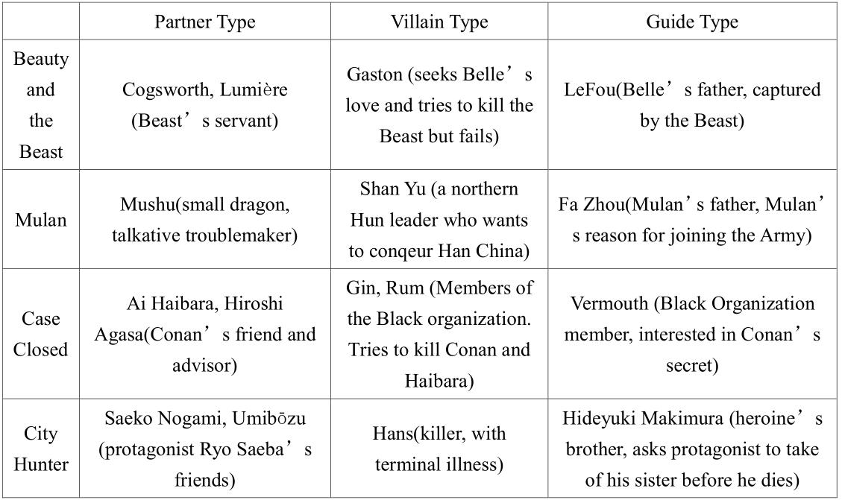
Fig. 4 Comparison of Supporting Characters before 2000.

Changes in time and regional culture have been echoed by continued development in animation production. Values of the real world, such as family, friendship and love are portrayed in works. Character images with clear good/evil distinction have now become much more multifaceted. [4] From this perspective, supporting characters after 2000 may be categorised into opposing, complementing and distracting roles.
Opposing-type: With clear personality, opposing supporting characters appear to have opposite personalities to protagonist. They often stand at odds with main characters, influencing the chance of circumstances around protagonists.
Complementing-type: They assume insignificant roles, relieving tension during story development and offering light entertainment as comic characters. They appear when story development is fast to ease tension, often in cute images.
Distracting-type: Distracting supporting characters are always around main characters, distracting or misleading characters or the viewers with their words and action. They directly or indirectly mislead main characters and other characters; they are used to turn the direction of story development and to build up tension.
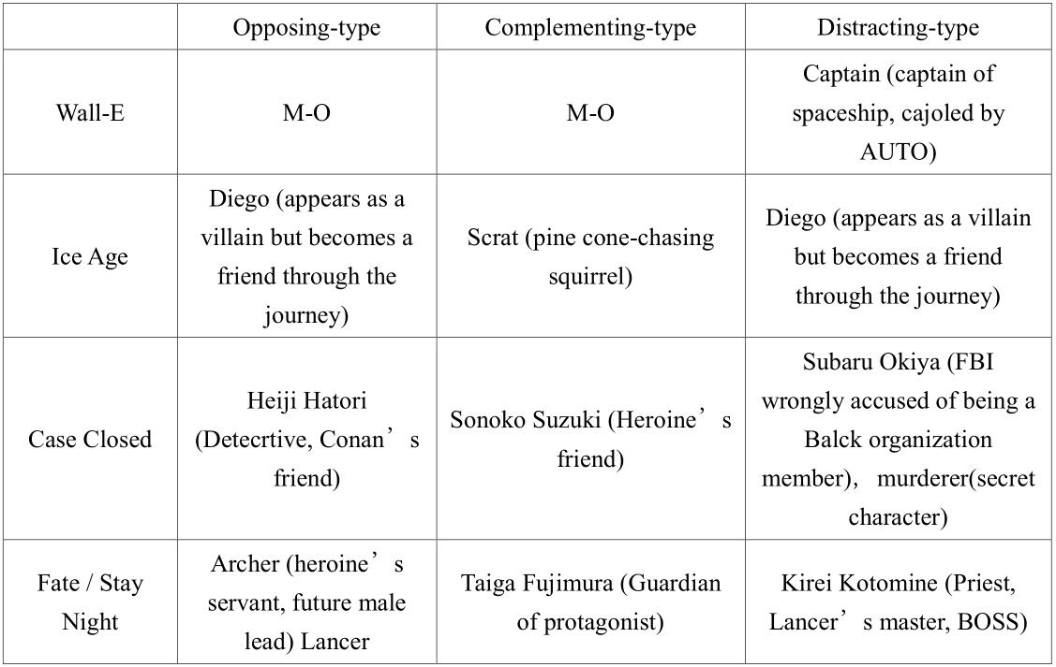

Fig. 5 Comparison of Supporting Characters after 2000.

IV. Conclusions

Thus changes in supporting characters in animation, which took place around 2000, have been described in 6 character types. From age to age, the personality of characters becomes more diverse and complex; and yet it should remain clear that supporting characters are there to emphasize the main character image. Supporting characters also influence the animation’s story; sometimes by inducing and controlling changes in storyline, humour is exercised. In <Ice Age>, the scene where a squirrel is running after a pine cone has no real relevance to the main story and will not affect the story development at large; and yet, it adjusts the rhythm of narrative by offering fresh entertainment, relaxing the audience and then returning to the main story. In TV series animation, the role of supporting characters has recently become important and the number of supporting characters is increasing. This implies that the role of supporting characters is becoming more important in developing the story and consistently engaging the audience. Authors believe that an analysis of supporting character is very important in such aspects.

References

[1] Yu, Haotian “The Comparative Study on Creation Mode of Supporting Role in American and Japanese Animation'' unpublished
- Wu,Yuhong, "Ciltural Thinking of Animation Characters Analysis of Popular Animation Characters from American and Japanese Cartoon in the past 100 years" in Journal of ZhejiangVocational Academy of Art, vol. 8, NO.1, P74-76.
- Wang, Chang, "Analysis of The Design And Methods of Supporting Role in The Chinese and Foreign National Animation" in Design 2016.02, P110-111.
- Wang, Chang, "Analysis of The Design And Methods of Supporting Role in The Chinese and Foreign National Animation" in Design 2016.02, P110-111.

